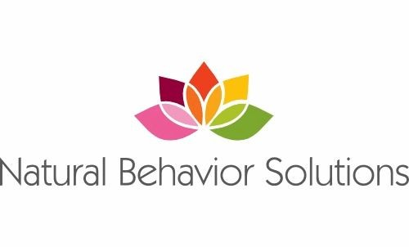
General Patient Information

Patient Name________________________________________________________ DOB______________________ Gender__________
Parent/Guardian Names___________________________________________Daycare/School/Grade________________________
Siblings/age___________________________________________________________________________________________________________
Phone (cell)__________________________________Work___________________________________Other________________________
Email____________________________________________________ How did you hear about NBS?_______________________
Location of Services(circle): Home School/Daycare Community
Address Home ________________________________________________ School _________________________________________
Availability(time/location)____________________________________________________________________________________
Medical and Psychological Info
Diagnoses and Date____________________________________________________________________________________
Psychologist who diagnosed_________________________________________Vineland date____________SRS-3____________
Medications____________________________________________________________Allergies____________________________________
Dietary Restrictions_______________________________________________________________________________________________
Primary Physician_______________________________________ Have you received ABA in the past?_____When?____
Other Therapies/Schedule___________________________________________________________________________________________
Communication (Circle): Verbal Non-Verbal Gestures/leading Sign Device/ipad PECS
Reinforcers/Preferred items/activities: _________________________________________________________________________
______________________________________________________________________________________________________________________
Restricted items: _________________________________________________________________________________________________
Sensory Issues/Aversive Stimuli (loud noises, soft touches/tickles, hugs, others laughing, etc)
_____________________________________________________________________________________________________________________

Behaviors of Concern /Severity of Behavior (bruising, bleeding, destruction of valuable property, skin damage, police involvement etc)__________________________________________________________________________________

_______________________________________________________________________________________________________________________

Strengths___________________________________________________________________________________________________________

Short and Long Term Goals__________________________________________________________________________________________

Payment Method (Circle One)
In Network Insurance: Tricare, Medicaid, CMS Title 21, Florida Blue, Blue Cross Blue Shield, CDC Waiver, Step UP (EMA), Aetna, and Sunshine Health. Private Pay: We also take all forms of credit cards, HSAs, Venmo/Zelle and checks.
Insurance ID _____________Policy holder/DOB_____________________________
Insurance active date Today’s date______________________

